Ideation Phase
define – the problem statements
Date | 30/10/2025
Time id | NM2025TMID05890
Project name | Calculating Family Expenses using Service Now
Maximum mark | 2 marks

Customer Problem Statement Template:
A customer problem statement clearly defines the issue from the customer's perspective to guide effective solutions. It typically starts by identifying who the customer is and what they are trying to achieve. Then, it highlights the obstacles preventing them from reaching their goal and explains the root cause of these challenges. Finally, it captures the emotional impact the problem has on the customer. For example, in a project to create a tool for calculating family expenses, the statement might be: "We are a family budgeting team trying to develop a simple and accurate tool for tracking expenses, but we struggle with data complexity and low user engagement because existing solutions are complicated. This leads to unreliable tracking and user frustration." This approach helps align the team by focusing on real user needs and challenges, ensuring the project targets the most important problems to solve.
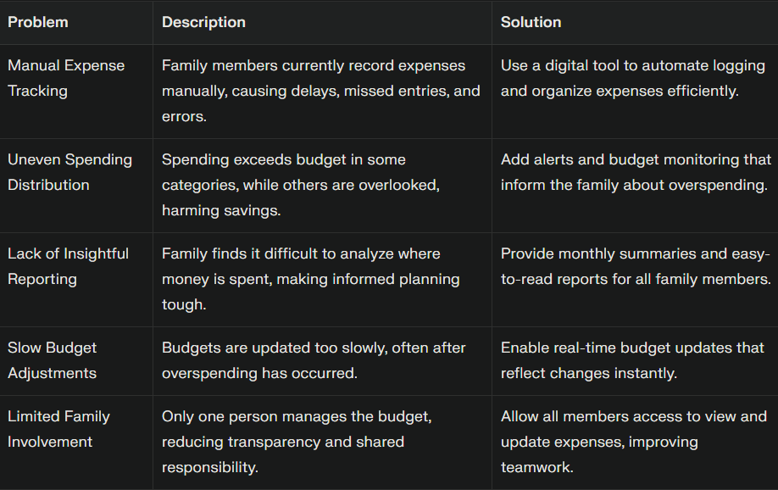
PROBLEM STATEMENT:

Problem | Description | Solution
Manual Ticket Assignment | Tickets are assigned manually, causing delays and errors. | Implement automated routing based on predefined rules and real-time data.
Uneven Workload Distribution | Some agents overloaded, others underutilized, reducing efficiency. | Introduce workload-balancing algorithms to evenly distribute tickets.
Lack of Skill-Based Routing | Tickets assigned without matching agent expertise, causing reassignments. | Create skill-matching mechanisms linking tickets to agents’ competencies.
Delayed Response Times | Manual sorting slows prioritization, leading to longer queues and slower service. | Use AI or rule-based prioritization for faster routing of urgent tickets.
Limited Visibility & Tracking | Team leads lack real-time insight into ticket flow and agent performance. | Develop live dashboards to monitor ticket distribution, status, and metrics.

